

ADMINISTRATIVE
SUPPORT TEAM
(255)

STATE – 2020

Production:

Job 1: Meeting Minutes (100 points)
Job 2: Letter with Mail Merge (100 points)
Job 3: Travel Itinerary (100 points)
Job 4: Spreadsheet with Formulas (100 points)
Job 5: Inventory Form (100 points)
TOTAL POINTS (500 points)

Graders: Please double check and
verify all scores and answer keys!

Property of Business Professionals of America.
May be reproduced only for use in the Business Professionals of America
Workplace Skills Assessment Program competition.

Grading Rubric

Job 1 – Meeting Minutes | Possible Points | Points Awarded
Minutes (follows mailability standards)  0 errors - 80 points, 1 error - 70 points, 2 errors - 50 points,  3 errors – 30 points, 4+ errors – 0 points | 80
Contestant ID and Job # in footer | 10
Minutes Printed | 10
Job 1 Total | 100
Job 2 – Letter with Mail Merge | Possible Points | Points Awarded
Letter (follows mailability standards)  0 errors - 60 points, 1 error - 50 points, 2 errors - 30 points,  3 errors – 20 points, 4+ errors – 0 points | 60
Data Source printed | 10
Merged code Letter | 10
2 Letters merged and printed | 10
Contestant ID and Job # in footer | 10
Job 2 Total | 100
Job 3 –Travel Itinerary | Possible Points | Points Awarded
Itinerary (follows mailability standards)  0 errors - 80 points, 1 error - 70 points, 2 errors - 50 points,  3 errors – 20 points, 4+ errors – 0 points | 80
Contestant ID and Job # in footer | 10
Itinerary printed | 10
Job 3 Total | 100
Job 4- Spreadsheet with Formulas
Data inputted correctly (follows mailability standards)  0 errors - 60 points, 1 error - 50 points, 2 errors - 40 points,  3 errors – 30 points, 4+ errors – 0 points | 60
Landscape Orientation (fits to one page) | 10
All table data is displayed | 10
Filters- Silver & Bronze Sponsors | 10
Contestant ID and Job # Centered in footer | 10
Job 4 Total | 100

Job 5- Inventory Form
Data inputted correctly (follows mailability standards)  0 errors - 70 points, 1 error - 60 points, 2 errors - 40 points,  3 errors – 30 points, 4+ errors – 0 points | 70
Form Design | 10
Fields formatted correctly (font, text size) | 10
Contestant ID and Job # on footer | 10
Job 5 Total | 100
TOTAL | 500

JOB 1: Meeting Minutes
PROFESSIONAL BUSINESS ASSOCIATES

Minutes

Regular Department Heads Meeting

February 13, 2020

The regular department heads meeting was called to order at 8 a.m. at Professional Business Associates in the sixth floor boardroom.

The following department heads were present: Julie Smith, Harvey Rosen, Tom Carlson, Roger Meyer, and Edna Renick.

The minutes from our previous meeting were approved.

Edna Renick Administrative Support Director reviewed the new training manual she developed for all the administrative assistants and shred the updated training dates that the administrative assistants will be participating in during the summer.

Julie Smith Human Resources Director shared the newly hired employees for the finance and marketing departments.

Tom Carlson Information Technology Director shared the schedule of maintenance on the all of the computers in the office and the installation of the new cybersecurity system.

Roger Meyer Marketing Director shared the new marketing campaign and public relations materials for the customer portal.

The next meeting of the department heads will be held on April 1st at 8:00 a.m.

There being no further business, the meeting was adjourned at 11:30 a.m.

(QS)

(2” line, right aligned) _________________________________
Secretary

JOB 2: Letter with Mail Merge
Note to grader:
Individual Merge Codes may be used.
Ex. <<First Name>> <<Last Name>>
Top Margin: 2”

Also: Make sure words highlighted were corrected with right spelling, and that the correct first names were inserted in the letters.

Current Date

«AddressBlock»

«GreetingLine»

As a new employee of Professional Business Associates, we would like to invite you to participate in the annual Fun Run sponsored each year by Professional Business Associates. Each year all employees participate in the Fun Run in many capacities. PBA employees can volunteer in many of the race stations, or can actually participate as a runner in the event. By volunteering or participating, this allows each employee to earn discounts on health insurance rates, a free Fit Bit gift certificate and a free membership to a local gym.

If you are interested in participating in the Fun Run, «FirstName», please let (Your Name) my administrative assistant know and (he/she) will get your name on the list of employees that will be participating in the Fun Run. (Your Name) will submit your name for your free Fit Bit and gym membership.

Looking forward to seeing you at the Fun Run.

Sincerely

Nancy Wells
CEO

Contestant #

Current Date

Mr. Patrick Hoops
6547 Ping Drive
Dayton, OH 80010

Dear Mr. Hoops

As a new employee of Professional Business Associates, we would like to invite you to participate in the annual Fun Run sponsored each year by Professional Business Associates. Each year all employees participate in the Fun Run in many capacities. PBA employees can volunteer in many of the race stations, or can actually participate as a runner in the event. By volunteering or participating, this allows each employee to earn discounts on health insurance rates, a free Fit Bit gift certificate and a free membership to a local gym.

If you are interested in participating in the Fun Run, Patrick, please let (Your Name) my administrative assistant know and (he/she) will get your name on the list of employees that will be participating in the Fun Run. (Your Name) will submit your name for your free Fit Bit and gym membership.

Looking forward to seeing you at the Fun Run.

Sincerely

Nancy Wells
CEO

Contestant #

Current Date

Mr. Jacob Wright
11289 W. Red Leaf Lane
Dayton, OH 80010

Dear Mr. Wright

As a new employee of Professional Business Associates, we would like to invite you to participate in the annual Fun Run sponsored each year by Professional Business Associates. Each year all employees participate in the Fun Run in many capacities. PBA employees can volunteer in many of the race stations, or can actually participate as a runner in the event. By volunteering or participating, this allows each employee to earn discounts on health insurance rates, a free Fit Bit gift certificate and a free membership to a local gym.

If you are interested in participating in the Fun Run, Jacob, please let (Your Name) my administrative assistant know and (he/she) will get your name on the list of employees that will be participating in the Fun Run. (Your Name) will submit your name for your free Fit Bit and gym membership.

Looking forward to seeing you at the Fun Run.

Sincerely

Nancy Wells
CEO

Contestant #

Job 3 Travel Itinerary
ITINERARY

Nancy Wells

May 4th- 6th, 2020

Monday, May 4th

6:25 a.m. Depart Columbus, John Glenn Columbus International Airport (CMH) Southwest Airlines, Flight 567 (non-stop)

10:05 a.m. Arrive Orlando International Airport (MCO) Take Uber XL to B Resort

7:00 p.m. Dinner Meeting at Ocean Prime with Charles Smith, Microsoft

Tuesday, May 5th

9:00 a.m Board meeting with Florida Tech Expo executive committee at Orlando Conference Center, 2nd floor Oceanside Room. (Breakfast will be served).

12:00 p.m. Hewlett Packard Luncheon, 4th Floor Ballroom, Orlando Conference Center.

2:00 p.m. Set up PBA Booth for the Florida Tech Expo, 4th Floor Ballroom, Orlando Conference Center

6:00 p.m. Dinner Meeting with PBA Information Technology Department, B Resort

Wednesday, May 6th

9:00 a.m Breakfast meeting with Florida Tech Expo vendors, 3rd Floor Ballroom, Orlando Conference Center.

12:00 p.m. Uber to Orlando International Airport

2:30 p.m. Depart Orlando International Airport (MCO) Southwest Airlines Flight 789 (non-stop).

5:10 p.m. Arrive at John Glenn Columbus International Airport (CMH)

JOB 4: Spreadsheet
Note to grader: These printouts do not reflect any shading or formatting. Please follow rubric for grading purposes. The second printout shows formulas.
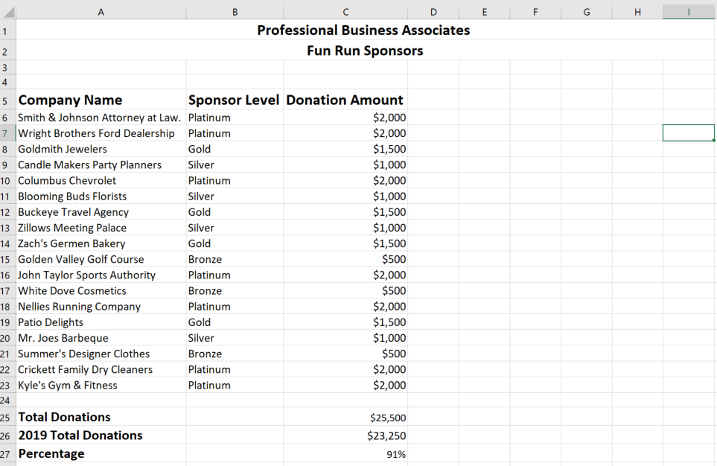

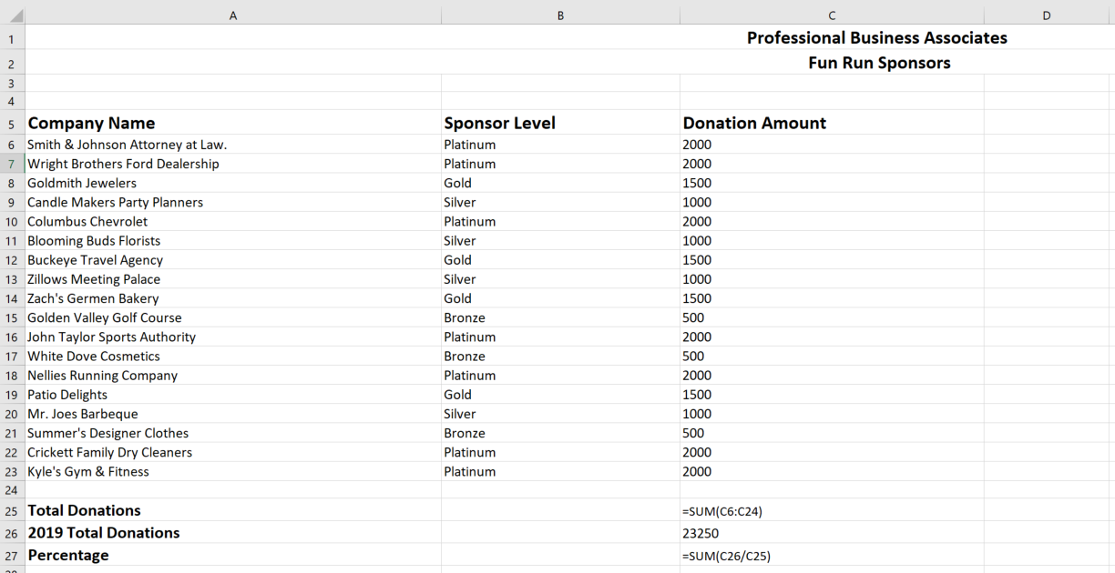
Spreadsheet with Formulas

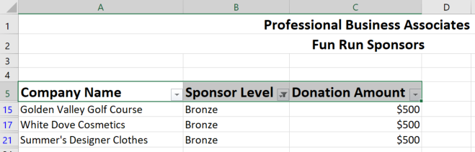
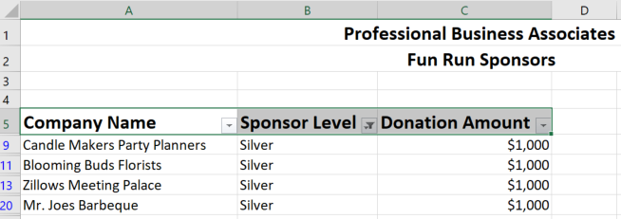

JOB 5: Inventory Form
Note to grader: There are several ways this form could be created. However, the directions asks them to create it in a table in Word. Please use rubric for grading purposes. The next page is an EXAMPLE. It could be a plain table.
Professional Business Associates
Office Supply Inventory

Product | No. of Items | Date of Inventory | Supplier
Calendars
Correction Tape
Correction Fluid
Envelopes
File Folders
Glue
Hole puncher
Paper
Paper Clips
Pencils
Pens
Rulers
Scissors
Stamps
Tape
Staplers
Staples
Printer Cartridges
Toners
Batteries
Hand Sanitizer
Highlighters
Signature

